Exp. No: 5 Determination and plotting of Electric potential difference between any two points in free space medium separated by a distance R.
Aim:
To write program for Electric potential difference between two points in free space medium using SCILAB.

Software required:
•SCILAB version 6.0.1

Program:
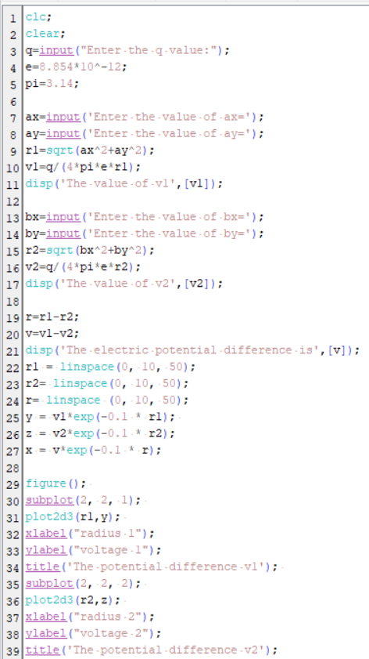
Output:-
Enter the q value:2*10^-2
Enter the value of ax=1
Enter the value of ay=4

"The value of v1"
43619068.

Enter the value of bx=36
Enter the value of by=64

"The value of v2"
2449209.3
"The electric potential difference is"
41169858.

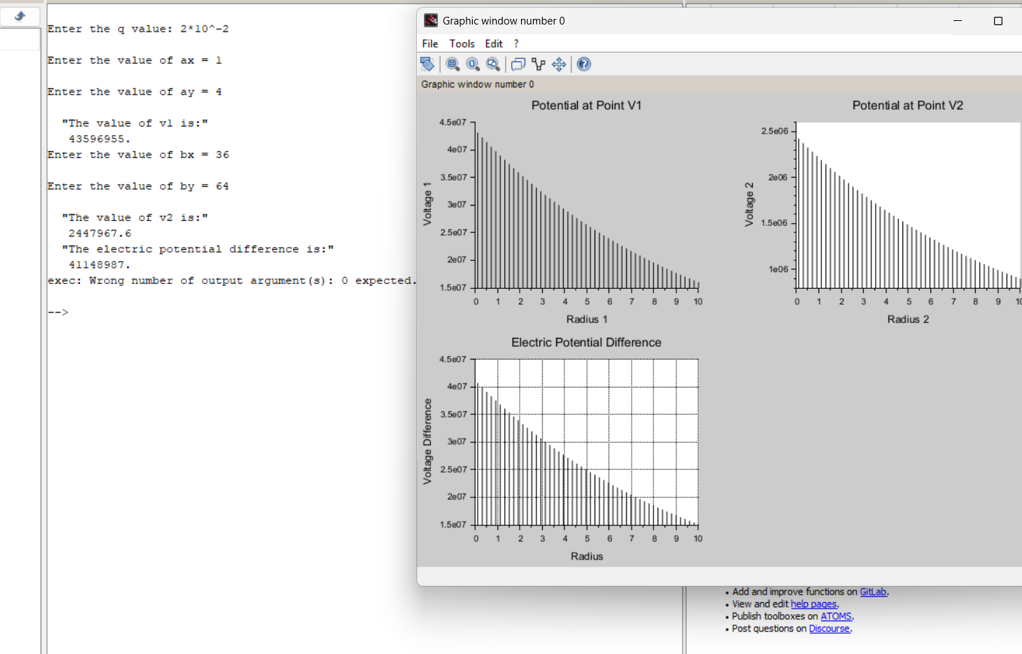
Case 1: A positive charge with fixed r1=1 m r2 varying.
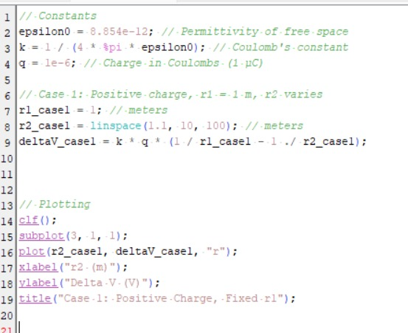
Output

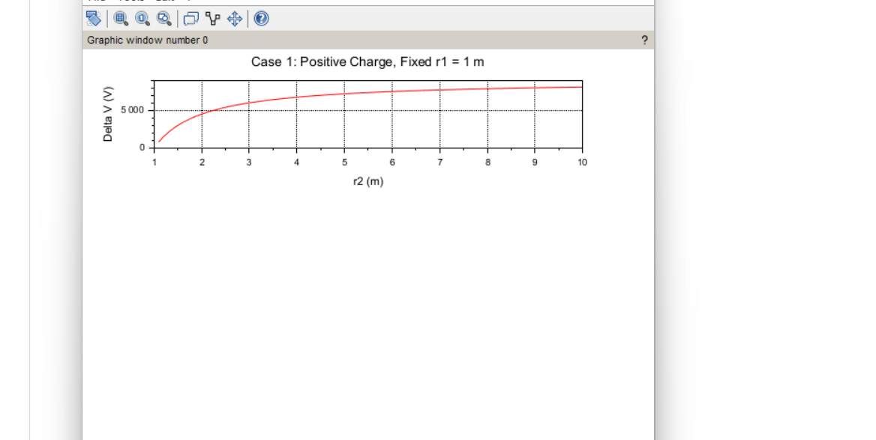

Case 2: A negative charge with r1r_1r1​ fixed and r2r_2r2​ varying.

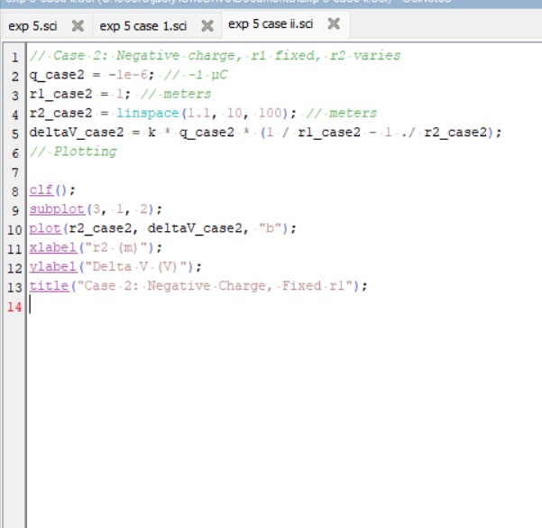
Output

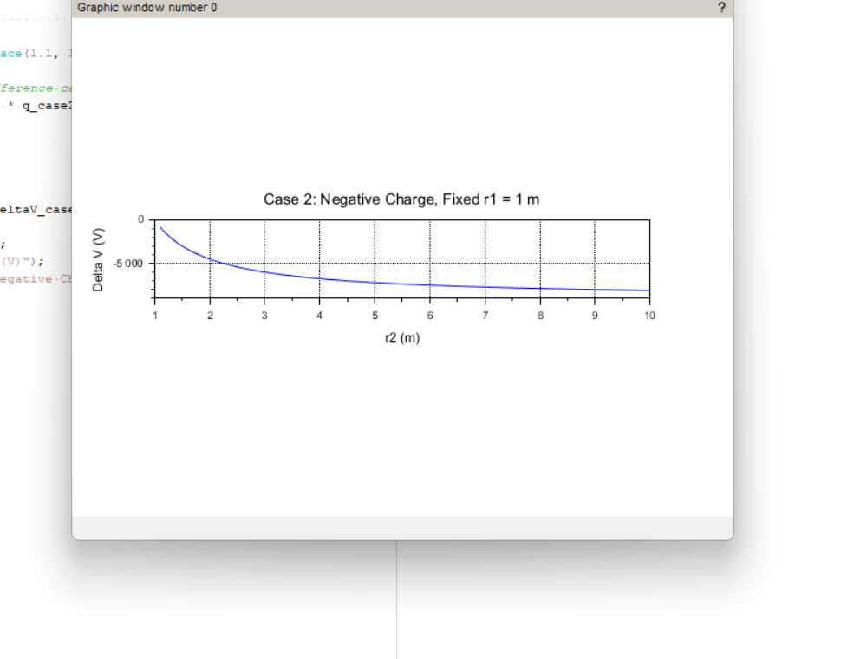

Case 3: Both points r1r_1r1​ and r2r_2r2​ vary with a positive charge.
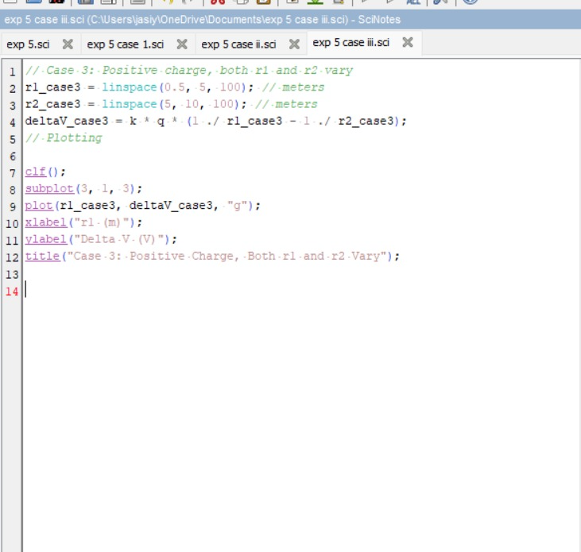
Output
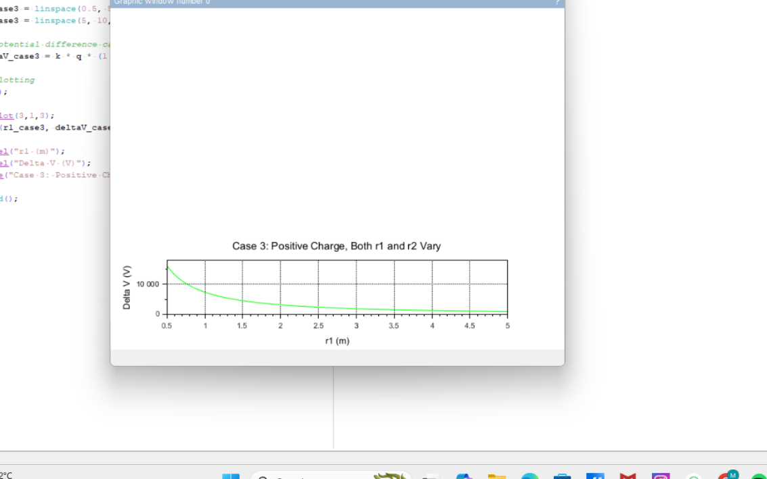

Result :
Thus the program was verified for Electric potential difference between two points in free space medium using SCILAB was successfully.

